

Ms Swathi
CH.VIVEK
2520030532
CSE
CO-4
Case study Topic: Civic Eye-Smart City Incident Monitoring & Response System

we implemented Shortest Path Optimization Algorithms for the CivicEye Smart City Incident Monitoring & Response System.
The system uses city road networks to determine the fastest emergency response routes.
Dijkstra’s Algorithm was applied to compute the shortest path from an emergency control center to incident locations.
The optimized routing system helps reduce response time and improves emergency service efficiency.

Implementation Details:
• Represented city roads and travel times using a weighted graph.
• Implemented Dijkstra’s Algorithm to find the shortest emergency response route.
• Calculated minimum travel distances from the control center to all incident locations.
• Used priority-based selection to choose the next nearest location.
• Improved route planning for emergency vehicles.
• Concluded that shortest path algorithms enhance smart city emergency response systems.
Result: Screenshots / output

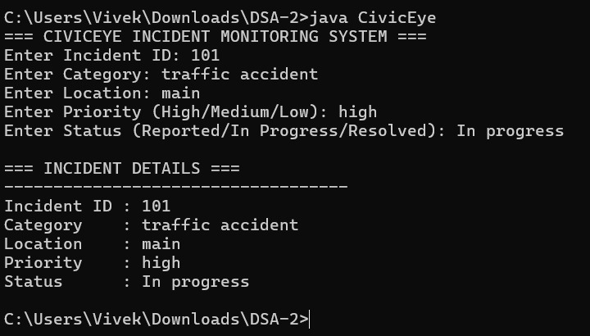

The implemented system efficiently handled event insertion, deletion, and retrieval operations.
Sorted event schedules were generated using traversal methods.
Time Complexity:
- BST Search/Insert: O(log n) average case
- AVL Insert/Delete/Search: O(log n)
- Tree Traversal: O(n)
Compared to normal BST, the AVL Tree provided better balanced performance for continuous event registrations and scheduling.

vivekcherukumalli7-beep/DSA2_CIVICEYE_PROJECT

